Show All Databases
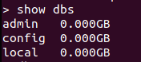

Create new database

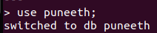

current selected database

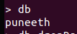

Drop database

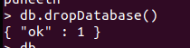

Create collection
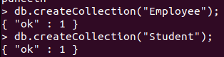

check collections list
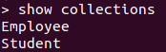

Drop collection

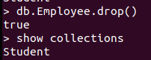

Insert document in collection

To insert single document
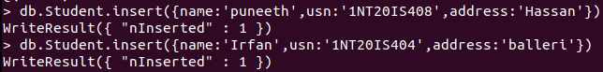
To insert multiple documents
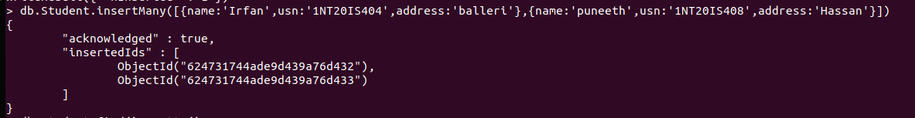

collection document

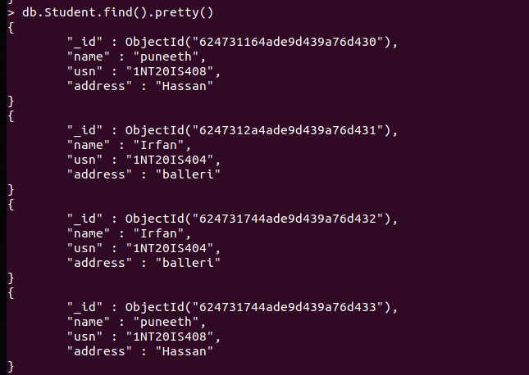

Update document

Unset :
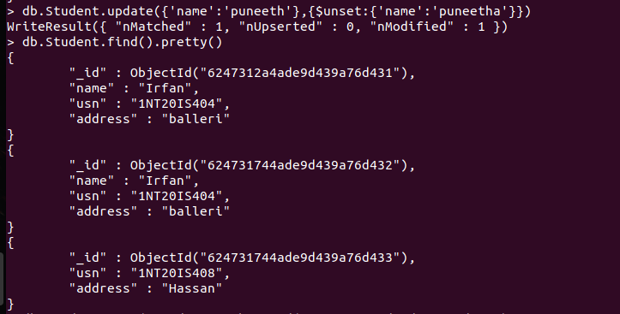

Remove or Delete:

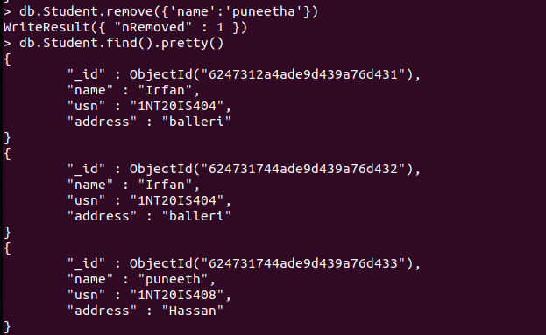

Replace:

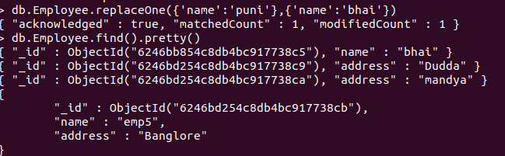

Save document
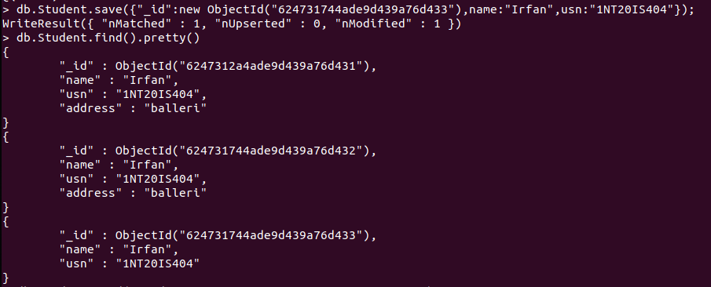

And command

Or command

